BILL NO. | AB 269
ACTION VOTED ON | Do pass and re-refer to the Committee on Appropriations
 | Aye : No | Aye : No | Aye : No | Aye : No
Roth, Chair | X :
Nguyen, V. Chair
Alvarado-Gil | X :
Archuleta | X :
Ashby | X :
Becker | X :
Dodd | X :
Eggman
Glazer
Niello | X :
Smallwood-Cuevas | X :
Wahab | X :
Wilk | X :
 | Ayes : 10 | Ayes : 0 | Ayes : 0 | Ayes : 0
 | Noes : 0 | Noes : 0 | Noes : 0 | Noes : 0

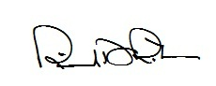
Date of Hearing: 02/27/2023 _______________________________________________, Chair

